MarketSense AI: Master Product & Technical Blueprint
The Gamified Flight Simulator for Intelligent Investing & Risk Management

1. Executive Summary & Vision
What is MarketSense AI?
MarketSense AI is an interactive, crisis-driven "flight simulator" for stock and multi-asset investing.
Just as airline pilots spend hundreds of hours in flight simulators practicing engine failures and turbulent storms before ever taking control of a passenger jet, MarketSense AI allows everyday people to experience 10 years of market booms, crashes, inflation shocks, and liquidity crunches in a 30-minute interactive session—without risking a single dollar of real capital.

The Problem We Are Solving
Most retail investors lose money in real markets not because they lack intelligence, but because of predictable behavioral traps and poor structural instincts:
- Panic-Selling at the Bottom: Dumping assets when red numbers flash, turning temporary paper losses into permanent capital destruction.
- The "False Diversification" Trap: Holding 10 different stocks and believing they are diversified, unaware that all 10 are tech/growth equities that crash simultaneously when interest rates rise.
- Ignoring Real-World Friction (Taxes & Fees): Day-trading and churning portfolios constantly, completely blind to how brokerage fees and short-term capital gains taxes erode long-term compounding.
- The AI "Black Box" Problem: Generic AI chatbots frequently hallucinate stock prices or give unverified, conflicting financial advice with zero audit trail.

The Solution: A Hybrid Flight Simulator
MarketSense AI pairs a deterministic financial pricing engine with a local, privacy-preserving AI mentor backed by a Macro-Financial Knowledge Graph. Grounded in the time-tested literature of Ray Dalio, Benjamin Graham, Howard Marks, and Peter Lynch, the platform teaches users why the market behaves the way it does, when to rotate into defensive "armor" (Gold, Sovereign Bonds, Cash), and how to build resilient, all-weather portfolios.


2. Core Financial Concepts & Gameplay Mechanics
To build genuine investing skill, the simulator introduces five foundational mechanisms:
1. The 5 Asset Pillars (Beyond Just Stocks)
True diversification requires holding asset classes that respond differently to the economic climate:
- Equities by Sector: Defensive Staples (FMCG, Healthcare), High-Beta Growth (Tech), Financials (Banks), and Cyclicals (Real Estate, Industrials).
- Sovereign Bonds: Short-term Treasury Bills (cash-equivalent yield) and Long-term Government Bonds (deflation and recession hedge).
- Hard Assets & Commodities: Physical Gold (the ultimate currency debasement and geopolitical hedge—"The Armor"), Silver, and Crude Oil.
- Liquid Cash Reserves: Dry powder earning money-market interest, ready to deploy into discounted bargains.
- Speculative / Trendy Assets: Crypto and Digital Assets ("The Adrenaline"—high volatility, narrative-driven).

2. The Real-World Friction Layer (Taxes & Fees)
Following John Bogle's golden rule ("In investing, you get what you don't pay for"), the game introduces financial friction:
- Brokerage & Exchange Fees: Flat $0.15\%$ fee deducted on every buy and sell.
- Short-Term Capital Gains Tax (STCG): Selling an asset held for less than 4 quarters incurs a heavy $25\%$ tax penalty on realized profits.
- Long-Term Capital Gains Tax (LTCG): Holding an asset for $≥4$ quarters discounts the tax penalty to $10\%$.
- Pre-Trade Warning: Before confirming a trade, an unskippable modal alerts the user:
"Selling this position now incurs $600 in STCG taxes and $20 in brokerage fees. Your net proceeds will be $9,380 instead of $10,000."

3. The Asymmetry of Losses (Negative Compounding)
The simulator physically demonstrates why capital preservation is job number one: $\text{Required Gain to Recover}=\frac{\text{Loss}}{1-\text{Loss}}$
- A $10\%$ loss requires an $11.1\%$ gain to break even.
- A $33\%$ loss requires a $50\%$ gain to break even.
- A $50\%$ loss requires a $100\%$ gain to break even!
Players learn why Warren Buffett's Rule #1 is "Never lose money" and Rule #2 is "Never forget Rule #1."

4. Market Inertia & State-Space Cycles
Headlines never hit markets in a vacuum. If a market is already in a Late-Cycle Tightening phase or undergoing Fiscal Year-End Tax-Loss Harvesting, background institutional selling pressure is high.
- A positive news headline arriving during this window will not spark a massive rally; it will result in a flat, muted market.
- The AI mentor explains: "The positive trade deal merely stopped the bleeding today because institutional fiscal year-end rebalancing created heavy background sell pressure."

5. Configurable Market Archetypes (Geography & Climate)
Markets reflect their physical geography and currency strength:
- Archetype A: Global Reserve Mega-Market (US-Style): Dominated by interest rates, tech valuations, and global liquidity. Insulated from local weather cycles.
- Archetype B: Monsoon & Rural Consumption Market (South Asia-Style): Sensitive to monsoon rainfall (which dictates rural FMCG and tractor sales) and imported crude oil prices.
- Archetype C: Commodity Exporter (Australia/Brazil-Style): Driven by global metal super-cycles and El Niño weather disruptions.

3. System Architecture & Technical Working
A critical design rule: The LLM never calculates stock prices.
- LLMs are probabilistic text engines; if asked to calculate prices, they hallucinate inconsistent numbers.
- In our Hybrid Architecture, a deterministic financial formula calculates exact prices, while the Local LLM and Knowledge Graph handle qualitative macro analysis and explanations.
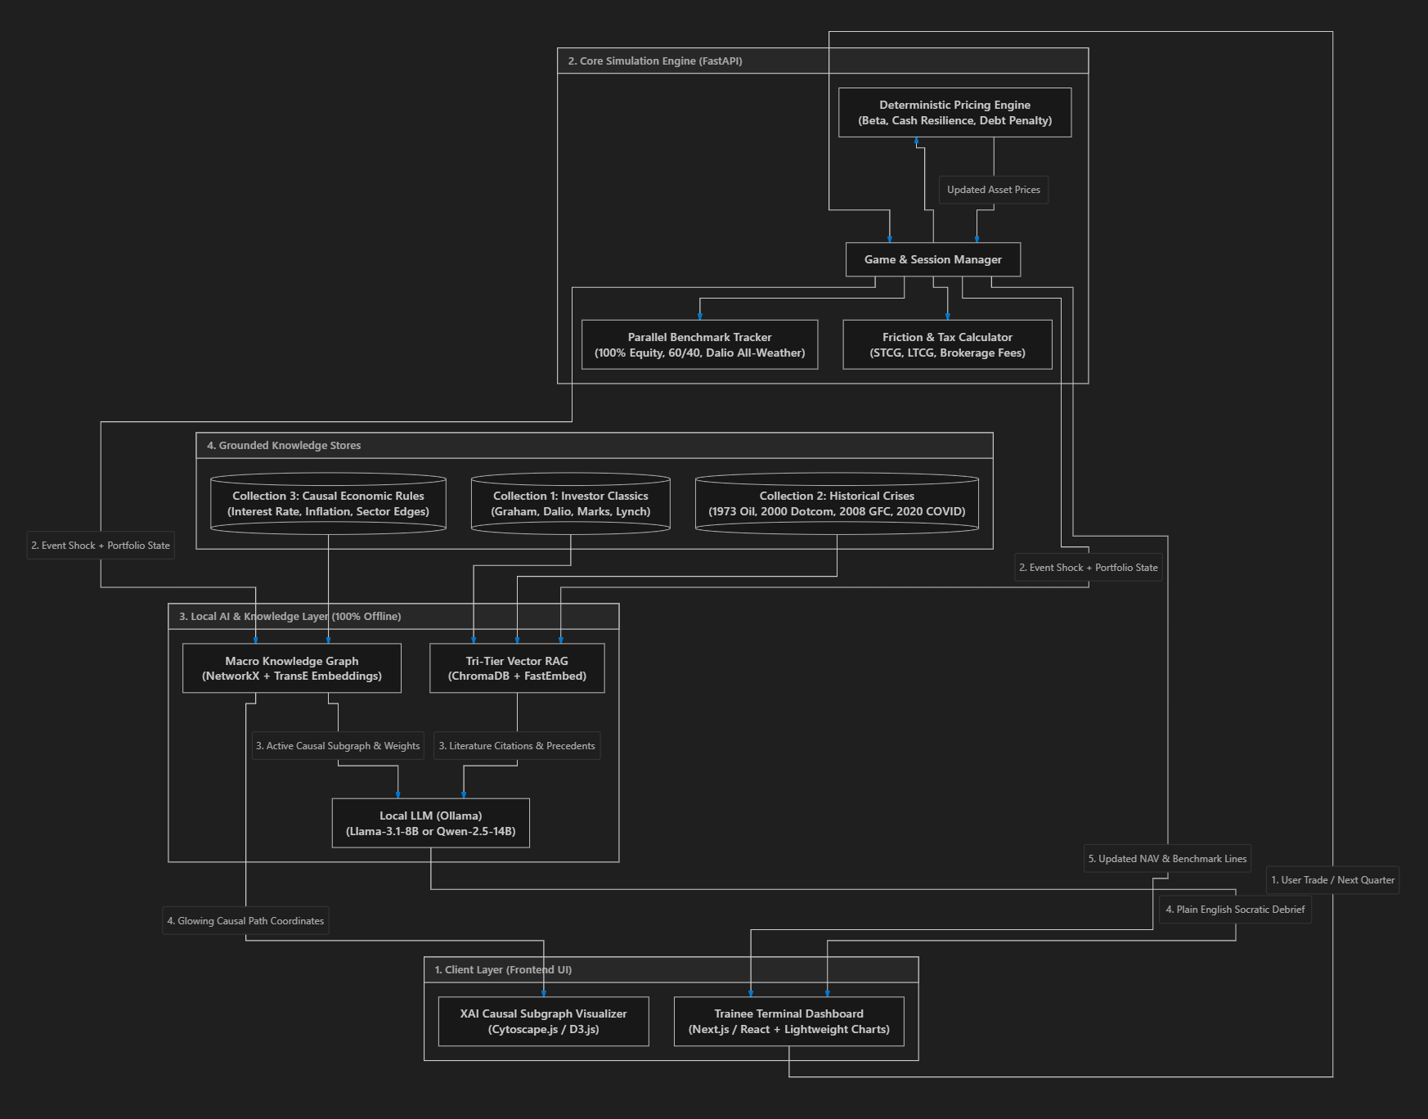

4. Explainable AI (XAI) via Knowledge Graphs
Standard AI is a "black box"—it tells you what happened, but you can't verify how it reached that conclusion.
MarketSense AI implements Neuro-Symbolic Explainable AI (XAI) by pairing the Local LLM with an explicit Macroeconomic Knowledge Graph:
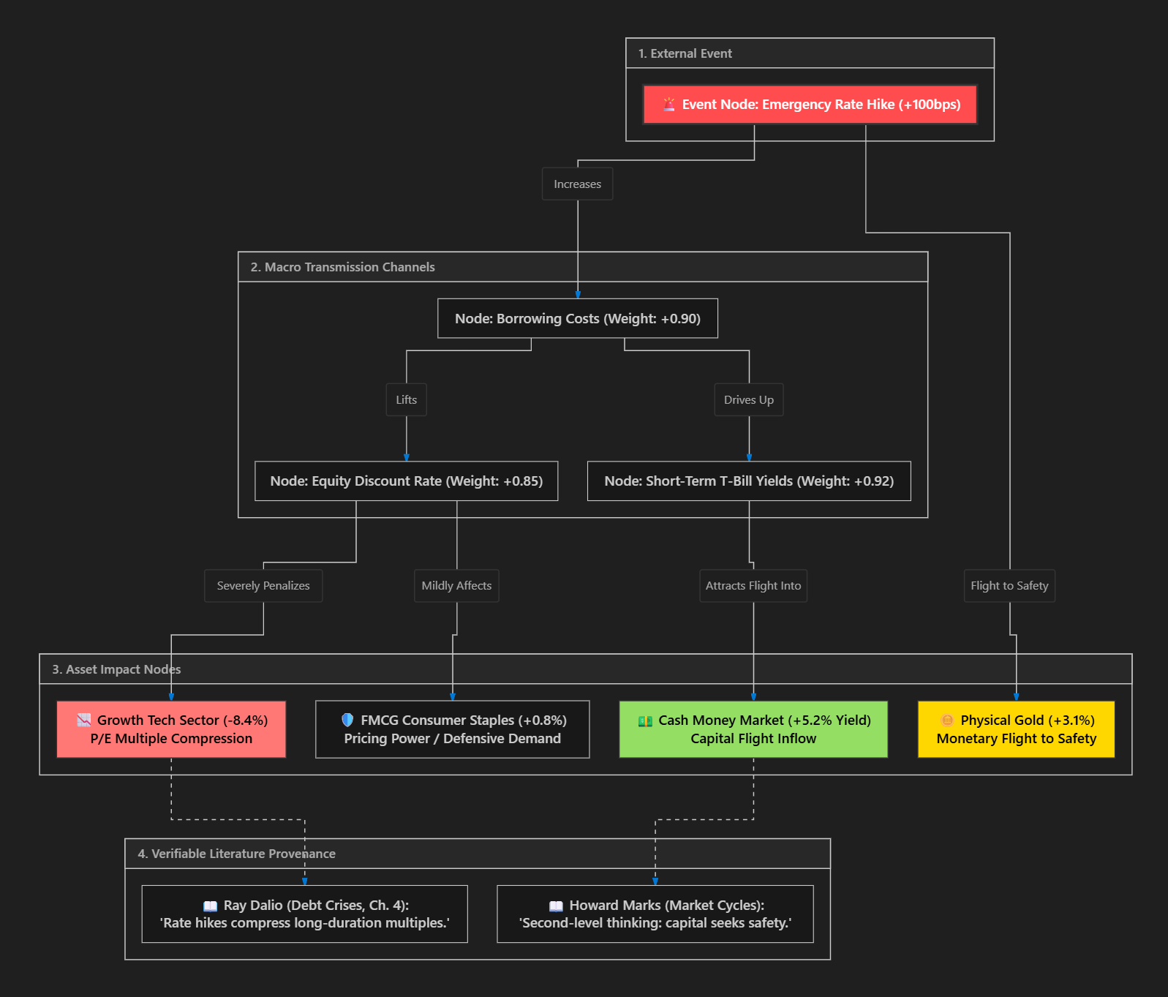
The 4 XAI Features Demonstrated in the App:
- Visual Path Attribution: When the LLM explains a crash, the exact cause-and-effect chain illuminates on the interactive graph. Hovering over a sentence in the chat highlights the corresponding edge in the diagram.
- Counterfactual "What-If" Explanations: The AI can explain:
"You lost $12,000 because your portfolio was 80% concentrated in high-beta tech. Had you held 20% Gold, the inverse transmission edge (+0.80) would have cushioned the fall, reducing your loss to $1,400."
- Clickable Provenance Citations: Every edge is backed by an unconflicted reference (e.g., Ray Dalio's Principles for Navigating Big Debt Crises or Howard Marks' Oaktree Memos). Clicking a node opens the source passage.
- 2D Knowledge Embedding Map: Assets are plotted on a 2D plane (via UMAP). Users visually see their portfolio's "centroid" and discover whether their assets are truly diversified or clustered in a single danger zone.

5. The Recommendation Engine: Market Baskets & "On-Demand CIO"
Why It Is Content-Based, NOT Item-Based Collaborative Filtering
- Item-Based Collaborative Filtering ("users who bought X also bought Y") fails in financial crises because retail crowds behave irrationally during panics. Learning from other users would train the engine to recommend panic-selling at the bottom.
- Instead, our engine is a Knowledge-Infused Content-Based Recommender: It analyzes the intrinsic economic attributes of each asset (Beta, Debt-to-Equity, Inflation Sensitivity) and matches them against the current macro crisis.
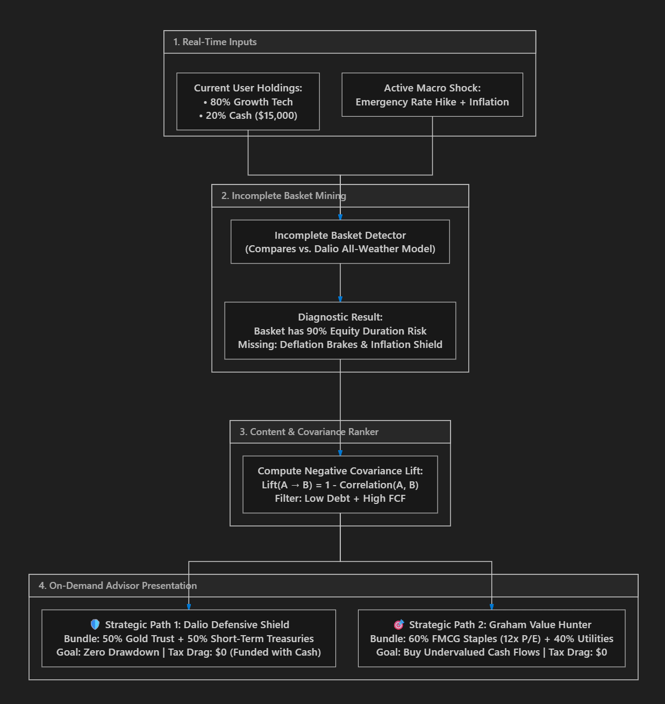
The [💡 Consult Advisor] Button (On-Demand CIO)
Recommendations are never forced on the user unsolicited. They trigger only when the user clicks the Advisor button:
- Portfolio Health Audit: Highlights concentration risks (e.g., "Warning: 80% allocated to rate-sensitive equities during a 100bps rate hike").
- Two Balanced Paths: Gives the trainee strategic autonomy—choose between Path A (The Defensive Shield) or Path B (The Contrarian Bargain Hunter).
- Tax Optimization Warning: Advises the user to fund new hedges using idle cash reserves rather than selling winning positions and incurring short-term capital gains tax.

6. Trainee User Interface & Interaction Design
The interface strikes a balance between the visual authority of an institutional financial terminal (Bloomberg/FactSet) and the intuitive playability of a strategy simulation:
+---------------------------------------------------------------------------------------------------------------+
| TOP HUD: Current Quarter: Q3 2024 | Macro Phase: Late Cycle (Tightening) | Portfolio NAV: $124,500 (+24.5%) |
| Cash: $15,200 (12.2%) | Benchmark Alpha: +4.2% vs S&P | Taxes Paid YTD: $1,420 | Brokerage: $180 |
+--------------------------------------------------------------------+------------------------------------------+
| LEFT PANEL: PORTFOLIO & BENCHMARKS (65% Width) | RIGHT PANEL: COMMAND & MENTOR (35% Width)|
| | |
| [TAB: Performance Curves] [TAB: Asset Allocation] | [ACTIVE CRISIS / MACRO CARD] |
| +---------------------------------------------------------------+ | +------------------------------------+ |
| | Interactive Multi-Line Chart (Last 12 Quarters): | | | 🚨 ALERT: Central Bank Emergency Hike | |
| | --- Trainee Portfolio ($124.5k) | | | "Fed hikes rates by 75bps to fight | |
| | ... Dalio All-Weather Benchmark ($118.2k) | | | runaway food/energy inflation." | |
| | -.- 100% Equity Index Benchmark ($104.0k) | | +------------------------------------+ |
| +---------------------------------------------------------------+ | |
| | [THE AI MENTOR TERMINAL (Socratic Chat)]|
| [HOLDINGS & TAX-AWARE LEDGER] | +------------------------------------+ |
| +---------------------------------------------------------------+ | | 🎓 Mentor (Howard Marks & Dalio): | |
| | Asset | Class | Alloc% | Return | Tax Status | Action | | | "Notice bond yields rising. Your | |
| |-------------+------------+--------+---------+------------+--------| | | long-duration tech stocks are now | |
| | TechIndex | Growth Eq | 35% | +28.0% | STCG (4mo) | [Trim] | | | under heavy valuation pressure. | |
| | FMCG-Alpha | Def. Eq | 20% | +4.5% | LTCG (14m) | [Sell] | | | What asset class historically | |
| | US 10Y Bond | Sovereign | 15% | -6.2% | LTCG (18m) | [Add] | | | acts as a buffer here?" | |
| | Gold Trust | Commodity | 18% | +14.1% | LTCG (12m) | [Hold] | | | | |
| | Cash (MMF) | Cash Eq | 12% | +3.8% | Risk-Free | [Deploy| | | [Type question to AI Mentor...] | |
| +---------------------------------------------------------------+ | +------------------------------------+ |
| | |
| [SECTOR HEATMAP: Cycle Sensitivity] | [TURN CONTROLS] |
| [FMCG: +1.2%] [IT: -8.4%] [Banks: +0.4%] [Gold: +3.2%] | [ 💡 Consult Advisor ] [ ➡️ Next Qtr ] |
+--------------------------------------------------------------------+------------------------------------------+
Key UI Features:
- Multi-Benchmark Visualizer: Tracks trainee NAV against three live reference lines:
  - 100% Equity Index: High volatility, deep crash drawdowns.
  - Traditional 60/40 Portfolio: Standard institutional baseline.
  - Dalio All-Weather Portfolio: Smooth, ultra-low drawdown baseline.
- Pre-Trade Friction Warning Modal: An unskippable modal appearing before every trade, detailing gross proceeds, capital gains tax, brokerage fees, and net cash.
- The XAI Inspector Split-View: Clicking "Why did this happen?" opens a side-by-side view showing the LLM narrative on the left and the illuminated, pulsing causal graph path on the right.
- Turn-Based Interaction: Users advance quarter by quarter through curated scenario arcs or by drawing from a 50-card Crisis Library.

7. Recommended Technology Stack
Layer | Recommended Tool | Why It Was Chosen
Frontend UI | Streamlit | Fast rendering, responsive financial charts, clean dark-mode terminal aesthetics.
Graph Visualizer | Cytoscape.js or D3.js | Interactive force-directed graph rendering with clickable nodes and highlighted causal paths.
Backend API | Python (FastAPI) | High performance, native integration with AI libraries and numerical computing.
Financial Math | NumPy & Pandas | Fast vectorized calculations for portfolio NAV, benchmarks, and compounding math.
Local LLM | Ollama (llama3.1:8b or qwen2.5:14b) | 100% offline, zero API fees, privacy-preserving, runs on consumer hardware.
Vector DB | ChromaDB or LanceDB | Serverless, file-based local vector store with metadata filtering.
Local Embeddings | FastEmbed (BAAI/bge-small-en-v1.5) | High-speed, lightweight embedding model running locally on CPU/GPU.
Knowledge Graph | NetworkX + JSON Specification | Lightweight, easy to query, update, and serialize into LLM context.

8. Phased Development Roadmap (4 Sprints)
⚠️ Failed to render Mermaid diagram: Invalid mermaid header: "gantt". Expected "graph TD", "flowchart LR", "stateDiagram-v2", etc.. Supported types: flowchart/graph, stateDiagram-v2, sequenceDiagram, classDiagram, erDiagram, xychart-beta.
gantt
title MarketSense AI Phased Implementation
dateFormat YYYY-MM-DD
section Sprint 1
Financial Engine & 3 Passive Benchmarks :2026-09-10, 10d
Taxes & Brokerage Friction Layer :2026-09-15, 7d
section Sprint 2
Macro Knowledge Graph & Tri-Tier RAG :2026-09-22, 12d
Local LLM Integration (Ollama + Schema) :2026-09-28, 8d
section Sprint 3
Market Basket Recommender & Advisor Draw :2026-10-06, 10d
XAI Inspector (Visual Subgraph Tracing) :2026-10-12, 10d
section Sprint 4
Interactive Trainee Dashboard UI :2026-10-20, 14d
Curated Crisis Campaigns & Beta Testing :2026-10-28, 10d

- Sprint 1: Core Financial & Friction Engine
  - Implement the 5 asset pillars and deterministic pricing formula (Beta, Debt, Cash).
  - Build the 3 parallel passive benchmarks (100% Equity, 60/40, All-Weather).
  - Build the tax (STCG vs. LTCG) and brokerage fee calculator.
- Sprint 2: The Macro Knowledge Graph & Local AI Mentor
  - Ingest timeless investor literature (Graham, Dalio, Marks, Lynch) into ChromaDB.
  - Define the Macro Cause-and-Effect Knowledge Graph in NetworkX.
  - Set up Ollama (llama3.1:8b) to parse event shocks into structured JSON scores.
- Sprint 3: Recommendation Engine & Explainable AI (XAI)
  - Implement Content-Based Incomplete Basket Detection using Negative Covariance Lift.
  - Build the on-demand [💡 Consult Advisor] drawer with Path A (Shield) and Path B (Bargain).
  - Create the XAI Inspector linking LLM text to illuminated graph paths.
- Sprint 4: UI Assembly & End-to-End Integration
  - Build the interactive Next.js dashboard with multi-benchmark charts.
  - Implement the Pre-Trade Friction Warning modal.
  - Assemble the 50-card Crisis Library and test campaign playability.

9. Next Steps for Your Team
This master blueprint is ready to be shared directly with your team. Here is what each team member can take away:
- Product / UX Leads: The clear user journey, emotional learning hooks, and intuitive layout.
- Backend / Quantitative Leads: The mathematical separation of pricing formulas from LLM text generation, ensuring zero hallucinations.
- AI / ML Leads: The clear roadmap for local open-source inference (Ollama), Knowledge Graph Embeddings (KGE), and Neuro-Symbolic Explainable AI (XAI).
Once your teammates review and approve this blueprint, we are ready to kick off Sprint 1!
8:03 AM
can collect all the insights ftom the begining and make a implmentation plan
Let me first review the full conversation history to ensure I capture every insight, decision, and design detail we discussed from the very beginning.
The comprehensive implementation plan is ready in the artifact viewer. Here's what it consolidates from our entire brainstorming session:
What's Covered (19 Sections)
Section | What It Contains
Vision & Problem Statement | The 4 behavioral traps we solve, the flight simulator analogy
17 Locked-In Design Decisions | Every explicit yes/no decision we made (no Pandora, yes Gold/Crypto, curated events only, conflict-free RAG, etc.)
Core Financial Mechanics | Negative compounding math, positive compounding via dividends, liquidity traps
5 Asset Pillars + Cross-Asset Matrix | Full shock-correlation table showing how 7 event types hit 6 asset classes
4 Market Archetypes | US, Monsoon/Emerging, Commodity Exporter, Industrial Exporter — with JSON config spec
Full System Architecture | Mermaid diagram wiring Frontend ↔ Math Engine ↔ Knowledge Graph ↔ RAG ↔ Local LLM
Tri-Tier RAG Design | 3 ChromaDB collections, 9 source types, metadata tagging strategy, and which investor gets triggered when
Knowledge Graph & Embeddings | Full entity/relation schema, TransE formula, vector arithmetic for hedge discovery, UMAP portfolio centroid
Explainable AI (XAI) | 4 XAI capabilities: Path Attribution, Counterfactual, Provenance, Embedding Map + the XAI Inspector UI
Recommendation Engine | Why NOT collaborative filtering, Content-Based + Market Basket + Negative Covariance Lift, thematic crisis baskets
Deterministic Pricing Engine | All 3 formulas (sector shift, individual asset, index recalculation) + LLM JSON schema
State-Space Cycle Inertia | How seasonal drag + macro momentum modulate shock impact
Friction Layer | STCG/LTCG rates, brokerage fees, pre-trade warning modal spec
Interaction Style | Dual-mode: Campaigns + Random Crisis Cards — why no free-form prompts
Dashboard UI/UX | Full component hierarchy Mermaid diagram + wireframe spec
7 Guardrails | Every safety rule in a single table
Technology Stack | 16 components across Frontend, Backend, and AI layers
Sprint-by-Sprint Gantt | 4 sprints with ~30 individual tasks, dependencies, and deliverables
10 Open Questions | For team discussion: MVP framework, stock naming, multiplayer, licensing, hardware

